21st Annual CFD Symposium, August 8-9th 2019, Bangalore.

**Aerodynamic Performance Study of NACA (653218) Wing with Cuff**

**R. Veerappan, M. Divya & K. Madhu Babu**

*Computational & Theoretical Fluid Dynamics Division,*

*CSIR-National Aerospace Laboratories, Bangalore -560017, INDIA.*

**Abstract**

The main objective of this study is to increase the aerodynamic performance of NACA six series (653218) rectangular wing by controlling the flow separation using wing cuff. An exploratory study was conducted to determine the effects of several leading edge droop modifications. In this work, RANS computations were carried out for different wing configurations (with and without leading edge droop)for several angle of incidences using CFD software ANSYS Fluent. This study showed that the cuff at leading edge has significant effect on resultant force coefficient of the wing over normal one, especially at stall angle of attack.

Keywords: *Leading edge cuff, ANSYS Fluent, Aerodynamic performance & Stall angle of attack.*

**Introduction:**

Due to depletion of fossil fuels, there is an increase in the price of aviation fuel and environmental pollution. At present, stalling and spinning of aircrafts are the major causes for fatal aviation accidents, which demands for advanced techniques in aviation. NACA 653218 shows extensive laminar boundary layer in the wind tunnel and flight test at large values of Reynolds numbers. Both tests revealed that the leading edge shape effects the magnitude of the pressure gradient [1]. The potential advantages at the stall afforded by wing leading edge modifications has been re-examined by the university of Michigan and NASA Ames research center [2,3] in an attempt to eliminate these earlier deficiencies. Recently the numerical investigation showed several benefits of modified wing with cuff over normal wing [4].

From the literature review, it is observed that the flow separation (adverse pressure gradient) and wall frictions are major factors affecting aerodynamic performance of the wing. In order to utilize the maximum available energy in the aircraft, it is necessary to increase the wing’s efficiency. Modification of wing is one such technique to enhance the aircraft’s performance by delaying the flow separation over the wing. The concept involved in this research was to modify the portions of the wing’s leading edge (droops) to control local stall progression and to produce better aerodynamic performance of the aircraft.

**Methodology:**

The leading edge cuff was used in this method to enhance the aerodynamic performance of the wing. Wing cuff dimensions were iterated to get an effective value for the creation of secondary vortex, which delays the flow separation over the wing as shown in figure 1. The design process of conventional wing and modified leading edge of the wing were carried by ANSYS design modeler. Specifications of the wing are given in table 1.

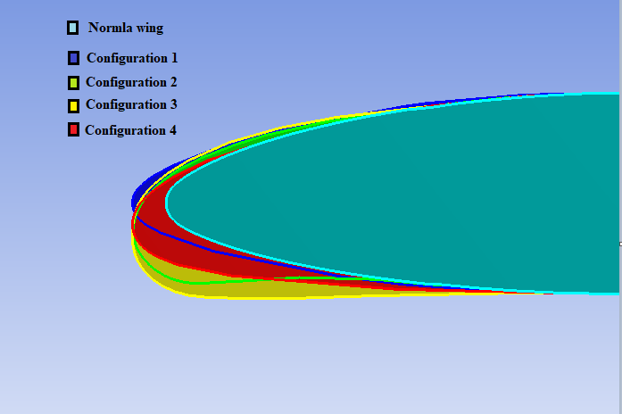

Figure 1. Different leading edge modifications

|  |  |  |
| --- | --- | --- |
| **S. No.** | **Description** | **Values** |
| 1 | Airfoil | 653218 |
| 2 | Wing | Rectangular |
| 3 | Wing Semi Span | 0.330m |
| 4 | Chord | 0.121m |
| 5 | Cuff Span | 40% |
| 6 | Cuff Chord Increase | 3% |
| 7 | Plan form Area Increase | 1% |

Table 1.Geometryspecification of rectangular wing

Meshing process carried out by ANSYS Workbench and C shaped topology chosen around the 3d geometry with unstructured tetrahedral elements. The computational domain, in which finer elements were generated near to the wing’s surface and gradually increases to the outer farfield as shown in figure 2. The first layer height was estimated as 8.5×10-7 with the Reynolds number of 0.3 million and Mach number of 0.1, used as flow parameters. More than 30 inflation layers have been generated around the wing body in order to get the hexagonal elements near the wing wall for better accuracy. Inflation layers has the ability to capture the viscous forces, which are more dominant in the region of viscous sub-layer of the turbulent flow as shown in figure 3.

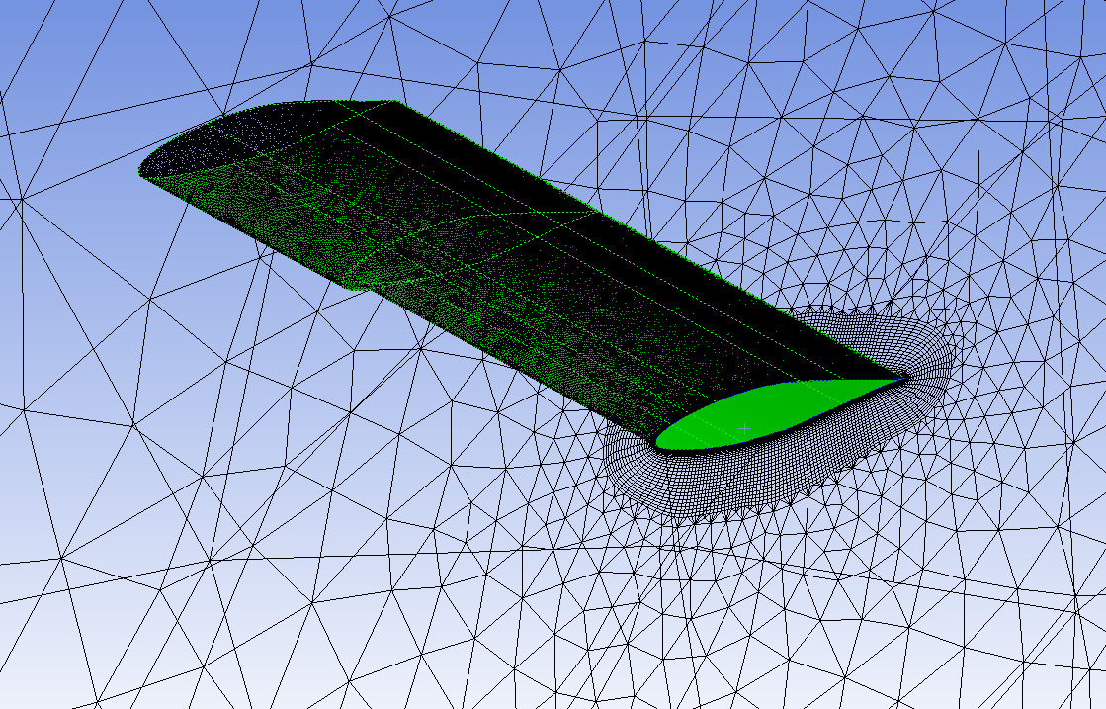

Figure 2. 3d mesh of rectangular wing with cuff

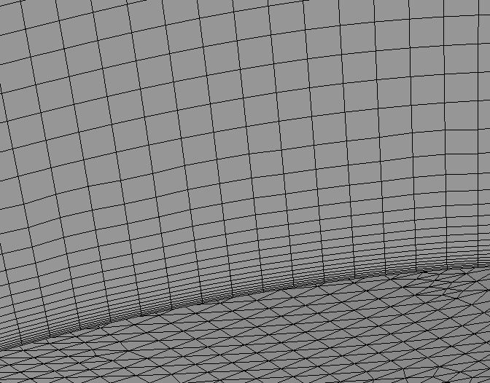

Figure 3. First layer height with inflation layers

|  |  |  |
| --- | --- | --- |
| **Grid type** | **Number of Elements** | **CL** |
| Grid 1 | 1587835 | 0.88516 |
| Grid 2 | 2156969 | 0.91863 |
| Grid 3 | 2310165 | 0.92184 |
| Grid 4 | 3544313 | 0.92234 |

Table 3. Comparison of solution with different mesh sizes

s

The grid independent test is carried out to arrive at optimal size of grid. The grid sizes of the grids are tabulated in table 3. From the table, grid 3 and grid 4 has a good comparison with experiments [5]. In this particular computation grid size of 2.3 million has been used (grid 3), instead of 3.5 million grid (grid 4) for reducing time requirements for computation.

Computational Fluid Dynamics(CFD) simulations carried out using commercially available ANSYS Fluent solver. Fluent solver uses a finite volume method to calculate unknown flow properties in the fluid domains by Reynolds Averaged Navier-Stokes (RANS) equations coupled with a turbulence model. The Fluent solver discretizes the RANS equation over each element and gives the non-linear equation for every variable at each node of the element by either pressure based or density based approach. In this present work, pressure based approach was used to solve incompressible flow with steady state condition. Spalart-Allmaras (SA) model was considered with air - ideal gas as the medium. The SA model is a one-equation model and also called low Reynolds turbulence model. It consists of one partial differential equation, which is used to solves for the turbulent viscosity, νt, then applied to the governing RANS equations. The SA model was designed specifically for aerospace applications involving wall-bounded flows and has been shown to give good results for boundary layers subjected to adverse pressure gradients. In ANSYS Fluent, the SA model has been extended with y+ -insensitive wall treatment (Enhanced Wall Treatment), which allows the application of model independent of the near wall y+ resolution. This formulation blends automatically from a viscous sublayer formulation to logarithmic formulation based on y+. On intermediate grids (1 < y+ < 30), the formulation maintains its integrity and provides consistent wall shear stress. Even after the y+ sensitivity removed, it is ensured that the boundary layer resolved with minimum resolution of 10-15 cells.

The operating pressure and temperature were taken at sea level conditions. The velocity of flow for the specified Reynolds number has been taken as 35 m/s. No slip wall conditions were used for the wing wall. Second order upwind discretization scheme was selected with respect to the mesh.

**Results and Discussion:**

The CFD analysis has been carried out for the flow over normal wing and a wing cuff to study the effects of wing cuff on lift and stall characteristics. In this study, four different cuff configurations have been considered for the range of angle of incidences. The figure 4 shows lift curves comparing normal wing with four different wing with cuff configurations. Normal wing shows higher Cl and stall angle as 220, whereas, all four wing with cuff configuration shows improved stall angle by 20. Cuff configurations 1, 2 & 3 are not providing improved CL, but configuration four shows higher CL with improved stall angle of 280.

The figure 5 shows the drag curves comparing normal wing to four configuration of wing with cuff. At lower angle of attacks drag has not modified much, but at higher angle of incidences CD has been decreased over normal wing. Wing with cuff four configuration shows higher stall angle, higher resultant lift coefficient and lower drag compared to the normal wing.

Figure 4. CL Vs Alpha Figure 5. CD Vs Alpha

Figure 6. CL/CD Vs Alpha

The figure 6.shows the Lift-To-Drag Ratio (CL/CD) curves for the normal wing and four configurations wing with cuff. The CL/CD ratio is higher for the configuration 4, particularly at high angle of attacks compared to normal wing.

Normal wing Cuff four

­­­­­­­­­­­­­­­

­­­­­

Figure 7. Cp plots comparison between normal wing and cuff four configuration

Figure 7. shows the coefficient of pressures comparing both normal wing and modified cuff wing (4th configuration) at 80% of the wing span for different angle of attack. From the figure, normal wing at 240 AoA flow is fully separated, whereas the fourth configuration cuff shown attached flow at even 260 AoA.

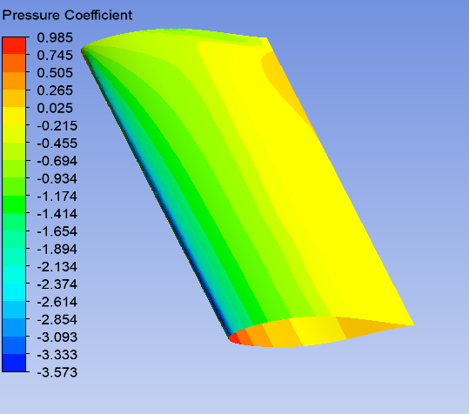 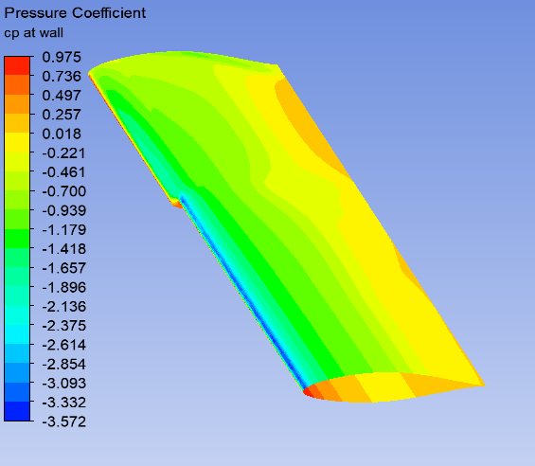

Figure 8a. Cp on normal wing surface Figure8b. Cp on cuff four configuration wing surface.

The aerodynamic performance of wing can be studied with the help of the distribution of the pressure coefficient. The surface pressure coefficients of cuff four configuration having minimum pressure values compared to the normal wing by energizing the boundary layer, as shown in figures 8a & 8b. The Cp contour of normal wing plotted at the stall angle of attack 220 as shown in figure 8a and at same angle of attack, cuff four configuration plotted for the comparison shown in figure 8b. The low pressure area increased in the chordwise direction by delaying the separation in cuff four configuration, in turn improve the coefficient of lift and stall characteristics.

Normal wing Cuff wing

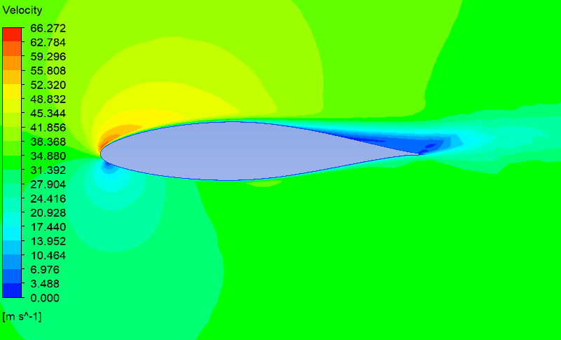 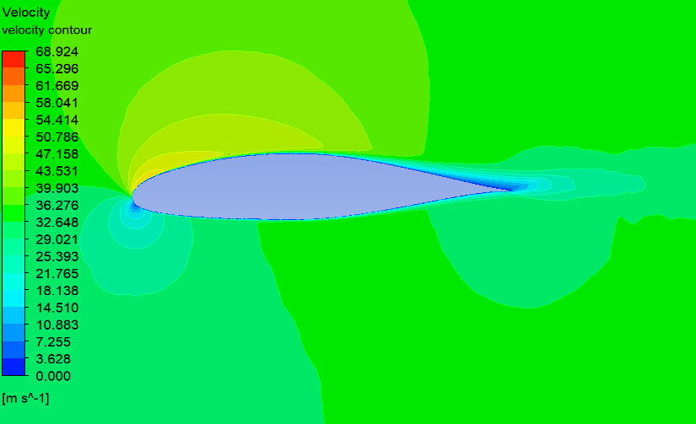

Figure 9. Velocity contour comparison at angle of attack 220 (80% of span)

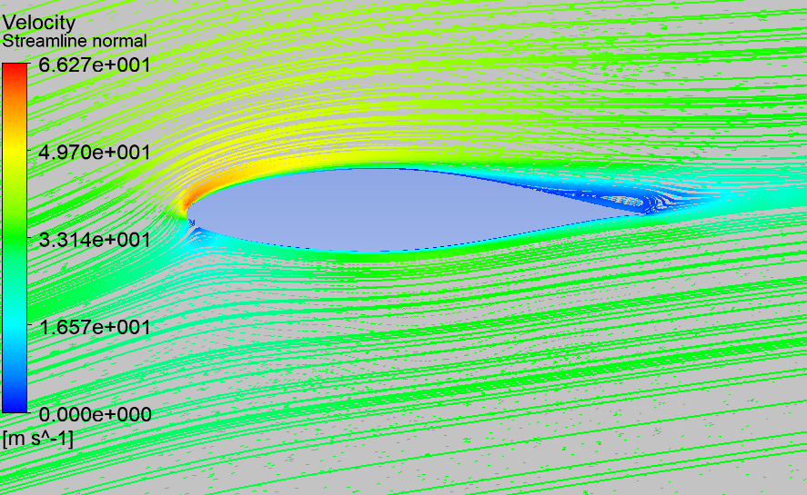 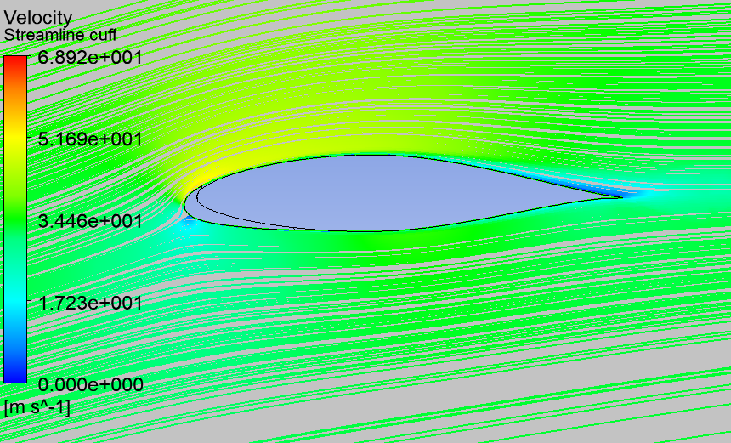

At stall angle of attack (22)

Figure 10. Stream line comparison between normal wing and cuff four configuration at 220

As shown in figure 9 and 10, The velocity contour and streamline patterns of normal wing is compared with the cuff four configuration at stall angle of attack for further exploration. The flow is accelerated at the leading edge of the suction side, as it moves further to higher pressure region of wing velocity reduced at the trailing edge. It has been observed through pressure and streamline contours at 220 flow is separated at the trailing edge, whereas cuff four configuration flow is attached on suction side of the wing. For cuff four configuration the stall angle is 280, because cuff part of the wing experiencing the less angle of attack than the normal wing, hence the flow separation delayed.

**Conclusion:**

Overall present simulations showed improved aerodynamic performance by increase in the lift and stall characteristics compared to normal rectangular 3D-wing. In this work, four different configurations with different leading edge shapes are studied. Out of which fourth configuration has given desirable performance of the wing. The outboard leading edge droop avoid early stall and at high angle of attack the flow is attached. This shows that the leading edge cuff can delay the critical stall beyond 22 degrees. The study showed that the increase in the stall angle of attack is due to delaying the flow separation over the wing by leading edge modification. We examined the wing with cuff configurations for different angle of incidences ranging from 0 to 300. The fourth cuff configuration increase the lift coefficients and minimize the drag coefficients compares to others. And also the fourth cuff configuration shows increase in the stall angle from 22 to 280over the conventional wing.

**Acknowledgement:**

This research work was supported by the CSIR-NAL. We are immensely grateful to Dr. J.S. Mathur, Head, CTFD and Dr. V. Ramesh, Joint Head for useful comments and suggestions to execute present work. We would like to acknowledge Sharanappa V Sajjan for his suggestions and finally, acknowledge ANSYS tool, which was utilized for the current study.

**References:**

1. R.Meby Selvaraj, P.Ebenezer Sathish Paul, M.Ramar, “*Computational Fluid Dynamic Analysis of Airfoil NACA 6 – Series*”,IJRSI ISSN 2321 – 2705,Volume I, Issue I, June 2014.
2. R.A. Kroeger, T. W. Feistel, “*Reduction of Stall –Spin Entry Tendencies Through Wing Aerodynamics Design*” (paper) 760481, Society of Automotive Engineers – April 1976.
3. T. W. Feistel, S. B. Anderson, and R. A. Kroeger,“*A method for Localizing Wing Flow Separation at Stall to Alleviate Spin Entry Tendencies*”, AIAA paper 78-1476, August 1978.
4. .S.M.A Meftah, M. Belhenniche, O Madani Fouatih and B. Imine, “*Effects of Wing-Cuff on NACA 23015 Aerodynamic Performances*”,EPJ Web of Conferences67, 020749(2014) DOI: 0.1051/epjconf/20146702074 _Owned by the authors, published by EDP Sciences, 2014.
5. Abhinivesh beechook, Jian wang, “*Aerodynamic Analysis of Variable Can’t Angle Winglets for Improved Aircraft Performance”,*conference paper – September 2013.
6. Brain Adams, Kevin Clark, Greg Davidson & Phill Spindler, “*Wing Cuff Design for Cessna CJ1*”, AAE 415 Project, Purdue University, Saturday, December 10th, 2004.
7. Hesham S. M. Helal, Essam E. Khalil, Osama E. Abdellatif, Gamal, M.Elhariry, *“Aerodynamic Analyses of Aircraft-Blended Winglet Performance”*, IOSR Journal of Mechanical and Civil Engineering (IOSR-JMCE)

e-ISSN: 2278-1684, p-ISSN: 2320-334X, Volume 13, Issue 3 Ver. IV (May- Jun. 2016), PP 65-72.